Performance Assessment: Manage Windows Users, Groups, and Access Control Lists (ACLs)

In this Performance Assessment, you will perform the tasks you have been taught in the Guided Practices. You may use the book, and any notes you have, along with the Linux man pages and Windows Server help utilities. You may look at your prior output. You may not give or receive help from other students. You may ask your instructor for assistance, but it is likely to cost points.

# Resources Needed

* Windows Server 2019 running in the VCASTLE Pod designated for this course
* CentOS 8 running the VCASTLE Pod designed for this course’s Performance Assessment

# Level of Difficulty

Medium

# General Considerations

You should be familiar with Linux and Windows networking. Secure Shell (ssh) is installed and configured on the Ubuntu server from a prior Guided Practice. Ansible is installed and configured on your CentOS Computer, and you have completed all the previous exercises. Consider running the playbook in increments and testing each section as you go. This may make troubleshooting easier and lets you takes advantage of the idempotency feature in Ansible (a playbook can be run multiple times without affecting initial settings).

# Instructions

|  |
| --- |
| **Warning with solid fill Important**: Please Note |
| All of your screenshots should include information that shows your login information. |

## Edit the Ansible Inventory (host) File

First, you will edit the Ansible Inventory (host) file to reflect your network architecture, if necessary.

1. View the inventory (hosts) file and ensure your inventory file reflects the architecture of your network as shown below and includes the [win:vars] section.

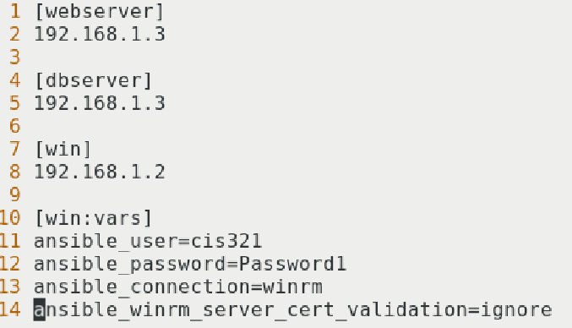

1. Write a Playbook to do the following:
   1. Create two Users (ECPIadmin and ECPIuser) and a new Group (ECPI) on Windows Server 2019.
   2. Create a directory on your Windows server (C:\ECPI) with an ACL that grants full control of the ECPI directory to the two new users.

**

1. Verify that the users have been created and **paste the screenshot here:** **Graphical user interface, text, application, email

   Description automatically generated**
2. Verify the Group has been created and **paste the screenshot here:** **Graphical user interface, text, application, email

   Description automatically generated**
3. Verify the directory has been created and ACLs have been applied to the ECPI group, and **paste the screenshot here:**  
   Graphical user interface, text, email

   Description automatically generated

# Rubric

|  |  |
| --- | --- |
| Criteria | Points |
| Screenshot 1 (Step 2) | 40 points |
| Screenshot 2 (Step 3) | 20 points |
| Screenshot 3 (Step 4) | 10 points |
| Screenshot 4 (Step 5) | 10 points |
| Screenshot 5 (Step 6) | 20 points |